Thành viên nhóm:
Lê Tấn Phát
Lê Tấn Quân
Phan Trần Phong
Hồng Đại Nghĩa
Tống Thành Thảo

Task 3: Architecture design
3.1 Use a layered architecture to design the HCMSIU-SSPS system. Describe how will you present your User Interface. Describe how will you store your data. Describe how you will access to external services/ APIs.
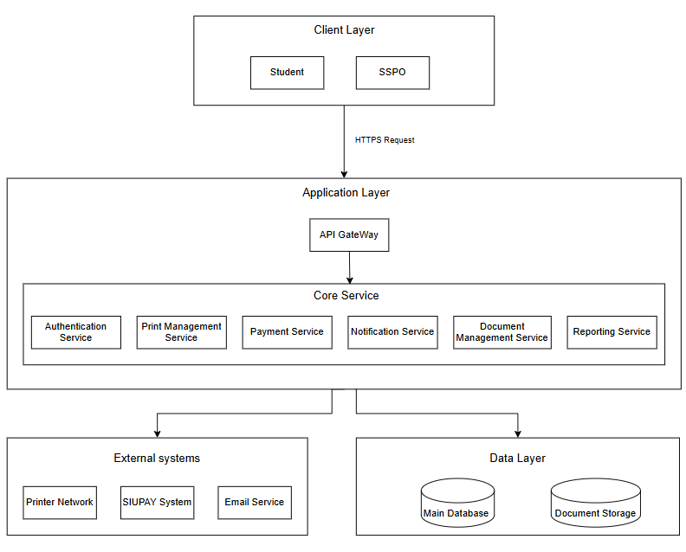
- Describe:
Client Layer: The Client Layer consists of two main entities: Student and SSPO (Administration). This layer focuses on the user interface to communicate with the internals of the system using the HTTPS protocol
Application Layer:
- The Application Layer includes the API Gateway, which receives requests from users, checks if they are valid, and then sends them to the appropriate service. This helps make the system more secure and organized. API Gateways are important because they handle much of the work for the backend, ensuring everything runs smoothly.
- The Core Service Layer contains the main features of the system, such as Authentication for logging in, Print Management for handling print jobs (such as printing documents, viewing print logs, managing printers, configuring the system, and viewing statistics), Payment for purchasing paper and viewing payment logs, Notifications for updates, Document Management for file storage, and Reporting for generating reports.
Data Layer: The Data Layer is where the system stores information. It includes a Main Database for things like user accounts and printing history, and Document Storage for uploaded files.
External Systems Layer: This layer connects the system to outside tools, like the Printer Network for printing, SIUPAY for payments, and Email Service for notifications. These connections save development time and allow the system to focus on its main tasks.
3.2 Draw a component diagram for an important module (the same with the module used in task 2.1)
3.2.1 Printing Process
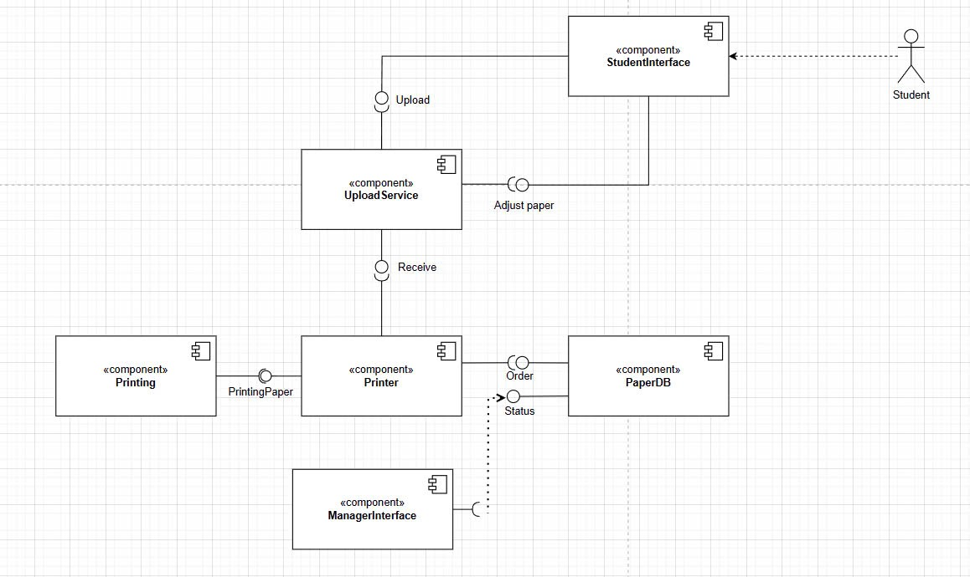
- Describe:
The component diagram illustrates the workflow of a smart printing service for students. It begins with the StudentInterface, where students upload files, adjust settings, and track order statuses. The uploaded files are processed by the UploadService, which validates and prepares them for printing. The Printer component acts as the core processing unit, receiving files from the UploadService and fetching order details from the PaperDB, a central repository that stores order data and statuses. The physical printing process is handled by the Printing component, ensuring that the final output matches user specifications. Additionally, the ManagerInterface enables administrators to monitor the system, manage orders, and resolve issues efficiently. These interconnected components work together to deliver a seamless and reliable printing solution.
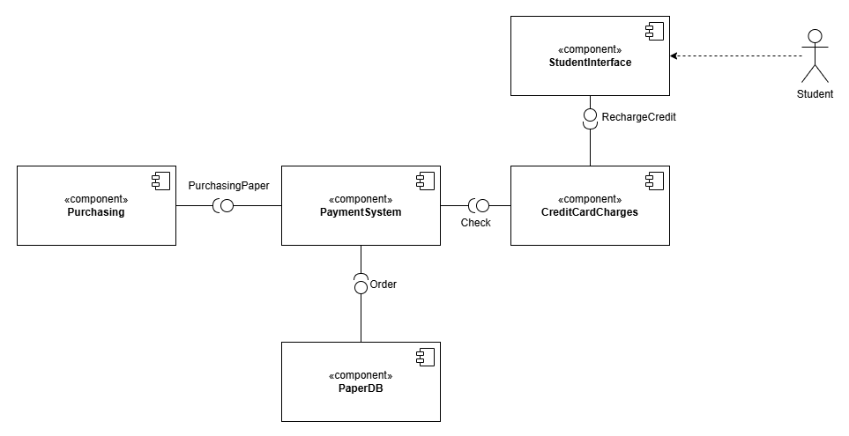
3.2.2 Buy Paper

- Describe:
The system allows students to purchase additional printing pages through an online payment gateway. The StudentInterface enables students to send their purchase requests to the PaymentSystem. The PaymentSystem communicates with the CreditCardCharges component to verify and process the payment. Once the transaction is successfully completed, the system updates the PaperDB to reflect the newly purchased pages.

